National Cheng Kung University
Department of Electrical Engineering

Introduction to VLSI CAD (Spring 2016)

Lab Session 4

Decoder & Adder

Name | Student ID
Practical Sections: |  | Points | Marks
Lab A |  | 30
Lab B |  | 30
Lab C |  | 40
Notes

Due Date: 15:00, March 23, 2016 @ moodle

Deliverables
- All Verilog codes including testbenches for each problem should be uploaded.
NOTE: Please DO NOT include source code in the paper report!
- All homework requirements should be uploaded in this file hierarchy.
- 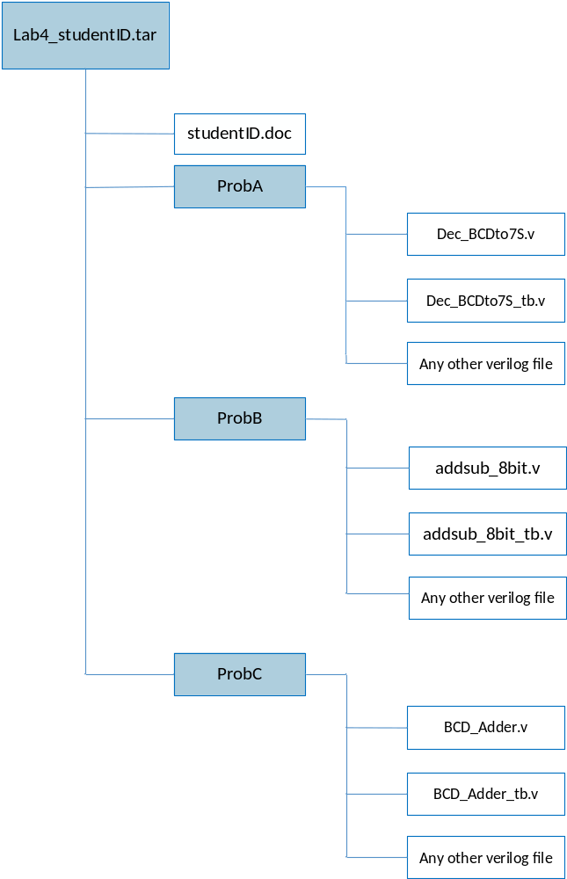NOTE: 1. Please DO NOT upload waveforms!

Fig.1 File hierarchy for Homework submission

Objectives:
To make you be familiar with the CAD tools (NC-Verilog & Debussy) that used for digital logic design. You can follow this document to practice, or you have a more clever way. Please show your best.
Prob A: Design Steps
- Understand the function of the target component.
Lab exercise 1-1: Write the Boolean function according to the truth table.
A | B | C | D | a | b | c | d | e | f | g
0 | 0 | 0 | 0 | 1 | 1 | 1 | 1 | 1 | 1 | 0
0 | 0 | 0 | 1 | 0 | 1 | 1 | 0 | 0 | 0 | 0
0 | 0 | 1 | 0 | 1 | 1 | 0 | 1 | 1 | 0 | 1
0 | 0 | 1 | 1 | 1 | 1 | 1 | 1 | 0 | 0 | 1
0 | 1 | 0 | 0 | 0 | 1 | 1 | 0 | 0 | 1 | 1
0 | 1 | 0 | 1 | 1 | 0 | 1 | 1 | 0 | 1 | 1
0 | 1 | 1 | 0 | 1 | 0 | 1 | 1 | 1 | 1 | 1
0 | 1 | 1 | 1 | 1 | 1 | 1 | 0 | 0 | 0 | 0
1 | 0 | 0 | 0 | 1 | 1 | 1 | 1 | 1 | 1 | 1
1 | 0 | 0 | 1 | 1 | 1 | 1 | 1 | 0 | 1 | 1
10~15 |  |  |  | 0 | 0 | 0 | 0 | 0 | 0 | 0
Table 1. Truth table
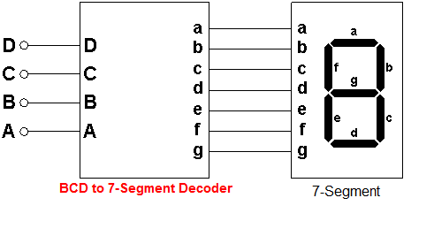

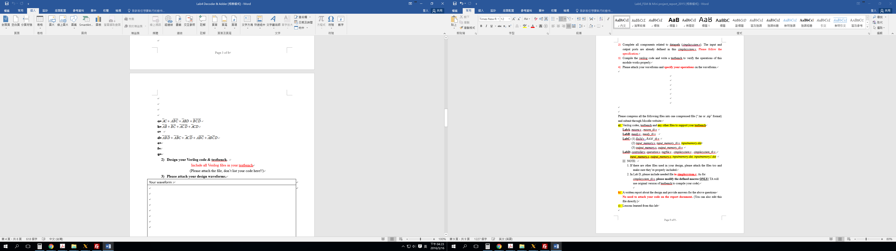

- Design your Verilog code & testbench.
Include all Verilog files in your testbench
(Please attach the file, don’t list your code here!!)
- Please attach your design waveforms.
Your waveform :
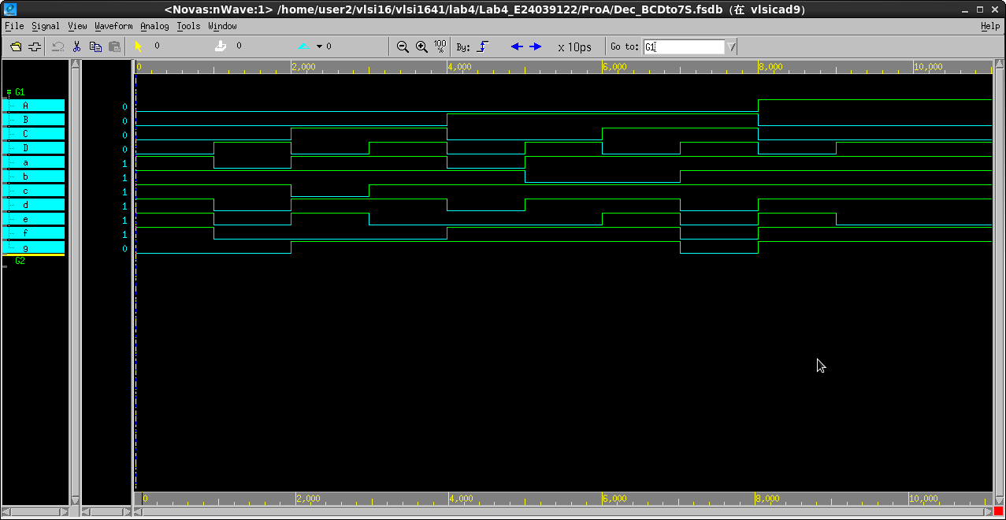

Explanation of your waveform :
它是由四個INPUT去解讀出七個OUTPUT
之後再顯示在顯示器上達到亮出數目字來
算是一個解碼器
當輸入為0000時,7-Segment,就會亮出0這個數字
以此類推

Prob B: Design Steps
- Draw the block diagram of 8-bit adder/subtractor.

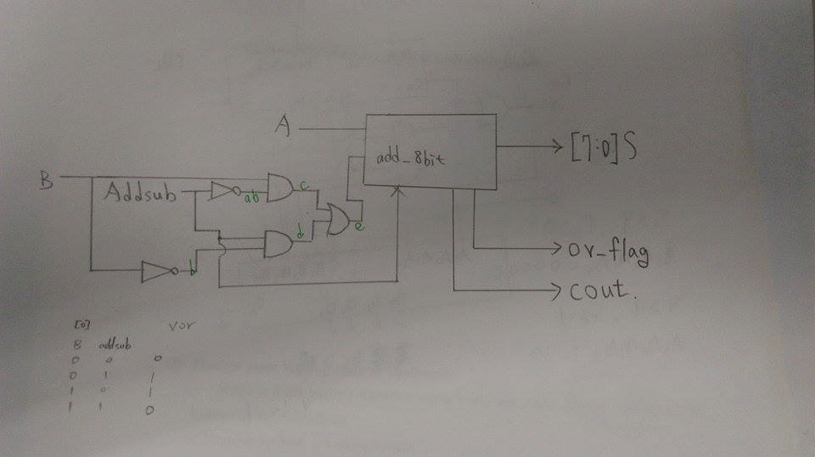

- Design your Verilog code & Testbench.
Write a 8-bit adder/subtractor using 1-bit full adder at gate level with the following specifications:
a. Number format: 2’s complement
b. Inputs: A[7:0]、
B[7:0]、addsub
c. Outputs: S[7:0]、cout、ov_flag
d. A[7]、B[7]and S[7]are the most significant bits for A, B and S, respectively.
e. If addsub = 0, A+B will be performed, otherwise, A-B will executed.
f. If the result is out of range (overflowed), ov_flag will be flagged to logic 1, otherwise, 0.
g. Please verify the following test pattern in your testbench .
Include all Verilog files in your testbench
h. Attach the file, don’t list your code!!
(i) 2+1,
(ii) 7+(-5)
(iii) 7+(125)
(iv) 22-(10),
(v) 22-(-125),
(vi) 22-26,

- Please attach your design waveforms.
Your waveform :
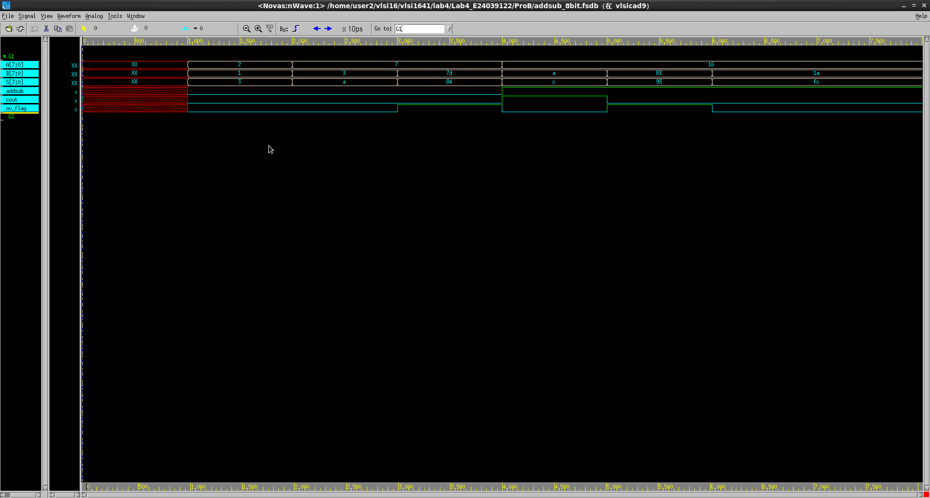

Explanation of your waveform :
先設計出一個8bit的加法器
之後用另外一個開關設計出add或是sub
當add時就自然的兩個數字相加
而當sub時就另一個數字反向後再加上一
最後就會產生出sum

Prob C: Design a circuit “2-digit BCD Adder”
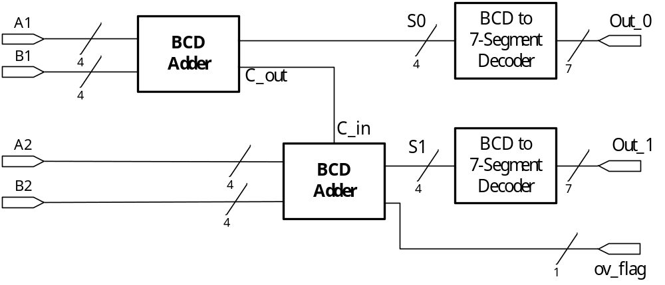
- Design your Verilog code & Testbench with the following specifications:.
a. Number format: unsigned number.
b. Inputs: A1[3:0], A2[3:0], B1[3:0], B2[3:0]
c. Outputs: Out_0[6:0],Out_1[6:0],ov_flag
d. Signal A1, A2, B1,B2 each represent 1digit BCD value
Signal Out_0, Out_1 each represent 7-Segment output a~g
e. Please verify the following test pattern , and included in your testbench .
- (05+08) ; A2= 0000, A1=0101, B2=0000, B1=1000
- (13+24) ; A2= 0001, A1=0011, B2=0010, B1=0100
- (51+09) ; A2= 0101, A1=0001, B2=0000, B1=1001
Include all Verilog files in your testbench
(Hint) : 1-digit BCD adder use two 4-bit Adder and some logic gates

- Please attach your design waveforms.
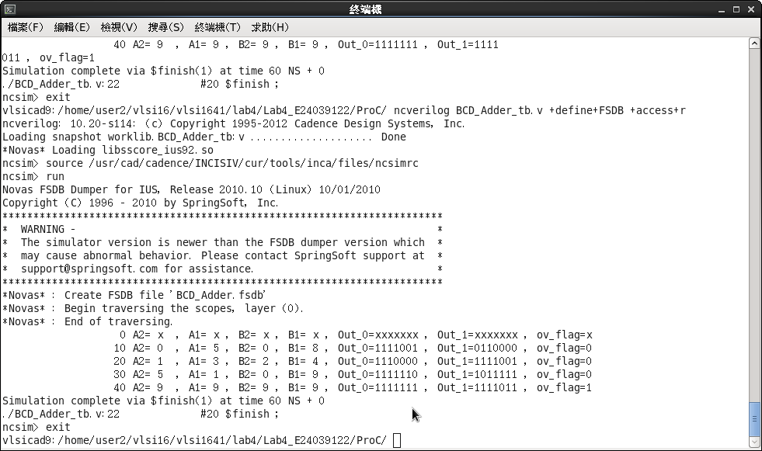
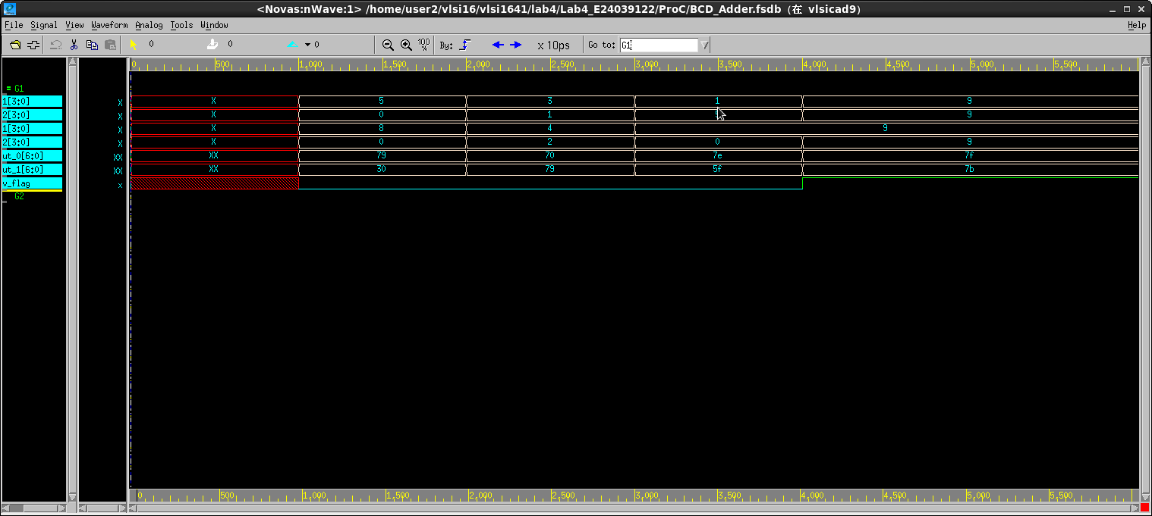
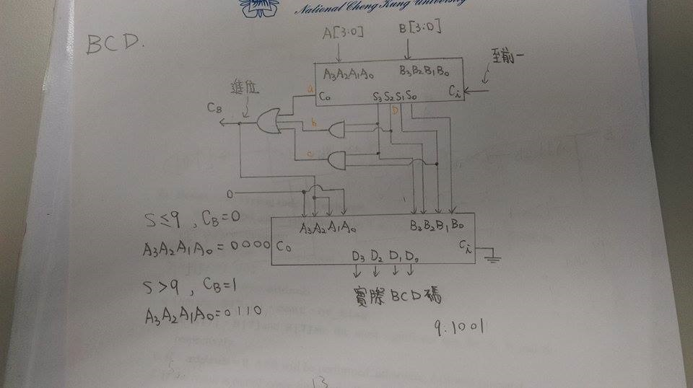

At last, please write the lessons learnd from this lab session, or some suggestions for this lab session, thank you.
這次實驗讓我學到很多東西,從老師上課精彩且詳細的介紹,還有助教詳細的解說實驗,讓我收穫許多,雖然之前有學過如何寫, 但是沒有這次講解的詳細,而且之前也有許多沒注意到的地方,這次就很清楚地避免,這次有要寫出Dec_BCDto7S,之前邏輯設計時有教過我們,之球覺得蠻難的,還有用one_fulladder去組合出add_8bit,再去寫出addsub_8bit,我覺得有些難要想很久,最後是組合出兩個BCD和Adder,讓我想了很久最後才終於寫出來,讓我獲益良多,也感謝助教和教授的指導,讓我抓出許多盲點以及缺失,覺得開心

